Student Travel Checklist

☐ Travel Authorization Form – To be completed at least 2 weeks prior to departure
- Who needs to sign?
☐ Traveler
☐ Traveler’s Professor/Chair
☐ Dean or VP
☐ If traveling outside of NYS or international, Provost will need to sign
Foreign Travel

☐ Meals
- Itemized receipts must be included for meals.
  - Meal per diems do NOT apply to students.
  - Alcohol will not be reimbursed.

☐ Standard Voucher
- Areas to complete on Standard Voucher:

Top portion – Payee Information
Do NOT add SSN
- Payee Name (first & last)
- Email Address
- Address (Street, City, State Zip) (where the check will be mailed to)

Middle Section – Description of Material/Service
- Dates and itemized listing of expenses (i.e. airfare, rental car, mileage, lodging, meals)
  - Meal per diems do NOT apply to students.
  - Itemized receipts required (without, they will not be reimbursed for that meal)
- Total Travel Expenses
- Net = Grand Total to be reimbursed

Payee Certification
- Student signs (no digital or e-signature allowed)
- Date

Supervisor’s Certification
- Dept Chair signs (no digital or e-signature allowed)
- Title
- Date

Cost Center Unit
- Add account # to charge
- Receipts & Backup
  - ☐ Scan all receipts & backup and combine into (1) PDF with Standard Voucher.
    - ☐ Email fully signed Standard Voucher and backup to accounts.payable@cortland.edu.
Standard Voucher cannot be digitally or e-signed.

Signature Types:
NOT Allowed:
- Typed signature:
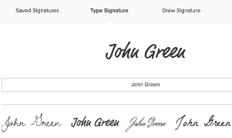
- Digital Signature:
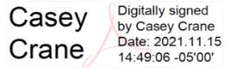
ALLOWED (original signature scanned):
- Original, scanned
